Program 1A and B



Program B

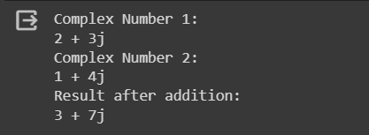

Program 2A and B



Program **b**

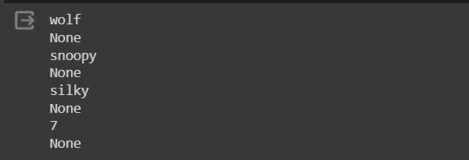

Program 3 A



Program B



Program4



Program5



Program 6 A and B

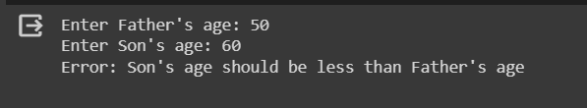

**Program B**



**Program 7**



**Program8**

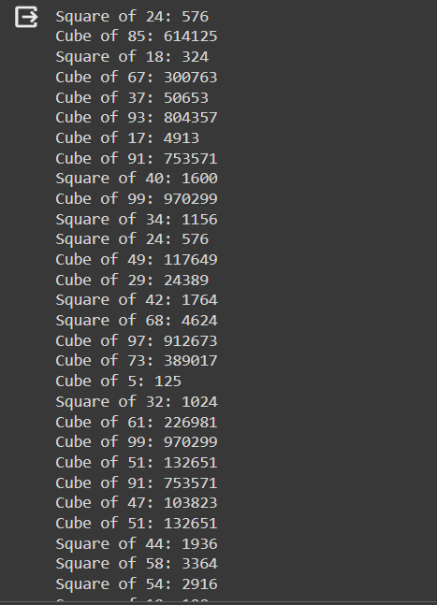

**Program9**

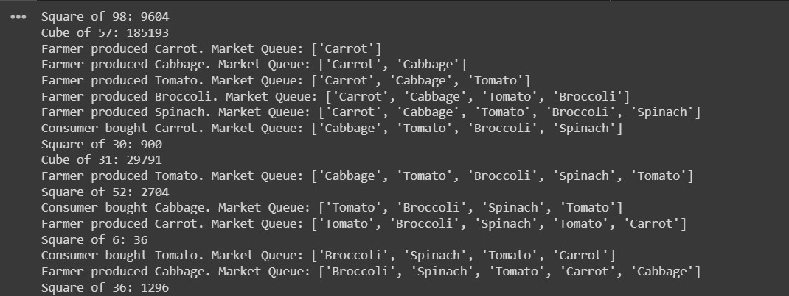

**Program10**

